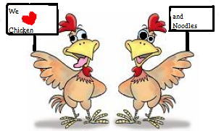
CHICKEN / NOODLE DINNER

BROOKSIDE FREE METHODIST CHURCH
190 EAST 400 SOUTH
KOKOMO, IN 46902

SEPT 16, 2017 4 - 7pm

TICKETS
Adults (11 & up) Advance $7.00

At the door $8.00

Children (4-10) Advance $5.00

At the door $6.00

Children 3 and under Free

TICKETS ARE ON SALE NOW

MENU
Chicken / Noodles
Mashed Potatoes
Green beans
CHOICE OF
Applesauce or Coleslaw
Bread & Butter
Drink

Dessert (extra dessert $1.00 each)

